Research Facilitation Fund 2026 - Call for applications

Summary
Versus Arthritis has provided ‘infrastructure’ funding in a variety of ways, from the centre of excellence and experiment treatment centre funding models to clinical studies groups and smaller scale initiatives supporting training summer schools, networking, collaboration management and scientific meetings. The value of such ‘soft infrastructure’ support (beyond buildings, facilities, equipment, data platforms and portals) has been convincingly emphasised to the charity by the research community.
Versus Arthritis recognises and understands the value of the charity as a facilitator of arthritis research as well as a direct funder of hypothesis-led science.
We appreciate how support for activities and resources that are hard for investigators to obtain improves the pace of the wider research agenda. Our Research Facilitation Fund is offering such support across the research spectrum.
This investment provides support for a variety of activities across the research pipeline environment including for example key personnel across technical and administrative support roles, research cohorts and biobanks. Over two years, we will invest approximately £1.5 million pounds over three rounds of funding. The second round of funding was dedicated to support of patient and public involvement activity. This is the third round of funding for this investment.
Applications are invited between £50,000-£250,000 in value, for up to 60 months duration.
This ring-fenced funding is about facilitating research and gaining access to hard to obtain resources with intent to leverage the speed of research delivery and allocation of funding to arthritis research. Investments will only be made where realistic impacts are sought towards bringing through ground-breaking scientific discoveries to people with arthritis at pace and with precision.
We want there to be better understanding of the causes and risk factors (biopsychosocial) for arthritis and other musculoskeletal disorders. We want to take the uncertainty out of clinical practice and improve policy around the diagnosis, prevention and treatment options for these debilitating conditions. We want to harness biological data and an individual’s lived experience to predict disease development and prognosis, identify the most effective, new interventions and minimise the risk of side-effects from long-term treatment.
Applicants must carefully read the application form and guidance documentation before starting an application. Please ensure that the most appropriate language is being used in each section of the form and that the correct sections are completed.
Applicants are invited to submit applications to this one-stage process through GrantTracker. The deadline for the receipt of applications is 16:00 on Wednesday 11th February 2026.
If you have any questions about this call document, eligibility or would like to discuss your research proposal with the office please email awards@versusarthritis.org

Context and Purpose
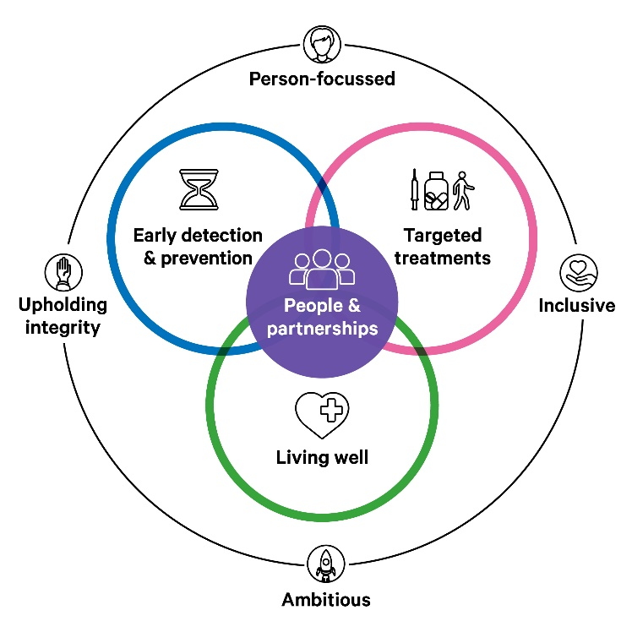
Over 10 million people in the UK are living with arthritis. As well as pain, people living with arthritis commonly experience high levels of fatigue, stiffness and loss of mobility and dexterity.
We want to bring about more precise and faster early detection and diagnoses, more effective and targeted treatments, and more holistic care. These are the key priority areas in our Better Lives Today, Better Lives Tomorrow Research Strategy 2022-2026. We are striving to bring ground-breaking scientific discoveries to people with arthritis at pace and with precision.

Over the last two decades, Versus Arthritis has provided infrastructure funding in a variety of ways, from the centre of excellence and experiment treatment centre funding models to the clinical studies groups and smaller scale initiatives supporting training summer schools and networks for epidemiology and allied healthcare professionals, collaborative networking and scientific meetings and distinct collaboration manager roles. This funding has provided support for a variety of activities including research cohorts and biobanks, for pump-priming projects, patient involvement and key personnel across technical and administrative support roles.
We recognise the value of Versus Arthritis being a facilitator of arthritis research as well as a direct funder of the hypothesis-led science. We appreciate how support for activities and resources that are hard for investigators to obtain improves the pace of the wider research agenda. Reflecting our understanding of the charity’s role as a facilitator and contributor to underpinning resources and services, our Research Facilitation Fund is offering such support across the research spectrum.
Investments will only be made to provide necessary additional resource to build, join up or drive musculoskeletal components or activities in given areas. A realistic projection of activity should be made for the use of funds and the nature of the existing resources, demonstrating the facilitatory value and intent.
Patient and Public Involvement (PPI) - The second round of funding was dedicated to support improved involvement in musculoskeletal research. Much good PPI practise has been established via Versus Arthritis funding. We have explored what researcher’s needs are around PPI and how and where Versus Arthritis support can provide best value across what has been generated. We wish to evolve and extend the knowledge bases, networks and resources that have been created in the PPI landscape for forward use by the entire research community.

Research Impact
The Versus Arthritis Research Impact framework focuses on the seven areas of research impact listed below. We anticipate that the Research Facilitation Fund can bring impacts across any of these areas potentially.
- Patient and Public Involvement: the benefit that patients bring to the research itself.
- New knowledge: our research has changed what we know about arthritis.
- Intellectual property, products, and services: new innovations, treatments or tools which improve patients’ lives.
- Policy and Practice: our research is influencing how arthritis is treated or managed.
- Partnerships: new networks, partners and collaborations which extend research.
- Leveraged funding: new funding that has been awarded to continue the research we funded.
- Capacity Building: our investments are increasing the human or technical capacity to conduct research

Research Facilitation Fund 2025 Awards
The first round of this funding call resulted in three awards:
- Biopsy investigation of Oxford Synovitis Cohort (BIOPSICO).
Professor Christopher Buckley, University of Oxford.
Enabling modest adjustments to be made to a dedicated clinical research space allowing the collection of small samples of patient tissue for research studies.

- The Manchester Musculoskeletal National Bioresource.
Professor Gisela Orozco, University of Manchester.
To ensure that the largest collection of arthritis patient samples in the world is maintained, added to, and made available to the research community.

- Norfolk Arthritis Register: Resource Enhancement for Sustainability and Translation (NEST).
Professor Alexander MacGregor, University of East Anglia.
To modernise and enhance the Norfolk Arthritis Register (NOAR), one of the most important resources for arthritis research worldwide with detailed health and biological information from over 5,645 people with new-onset inflammatory arthritis followed since 1989.

Scope and Requirements

Key Features / Fundamental Elements
- Applications do not require contributions from host/member organisations.
- Investments will only be made to provide the necessary additional resource to build, join up or drive musculoskeletal components or activities in given areas. A realistic projection of activity should be made for the use of funds and the nature of the existing resources, demonstrating the facilitatory value and intent.
- Patient and Public Involvement network support is excluded from Rounds 1 and 3.

Scope
Funding applications should be made with reference to the detailed inclusions / exclusions table below. Some notable potential areas for support are:
- Networks (brand new or re-energising) - meetings, manager role
- Creating or maintaining a research pipeline environment
- Further sustaining or evolving Centre of excellence and Experimental Treatment centre resources
- It is not to fund a PhD programme.

Networking
Scientific Exchanges | ü | Costs for travel and accommodation
Setting up and maintaining a network | ü | Not travel costs
Setting up symposiums, seminars, workshops, think tanks / sandpits | ü | Not travel costs
Sponsorship of meetings | x
Involvement
Patient and Public Involvement costs (payment of time) | ü | Where directly associated with the nature of the activity within the application.
Core Management Roles
PPI Management and Administration | ü | Patient and Public Involvement Network support is excluded from Rounds 1 and 3.  Such support for registries and biobanks is allowable
Network Managers | ü
Administrators | ü | Only for dedicated key areas – where time can be charged to the award
Contracts support | ü | Only for dedicated key areas – where time can be charged to the award
Regulatory support | ü | Only for dedicated key areas – where time can be charged to the award
Commercialisation / technology transfer / translation support | ü | Only for dedicated key areas – where time can be charged to the award
Patent applications fee / Licencing cost | x
Resources (creation / maintenance)
Patient (Longitudinal) cohort studies | ü | Support considered for existing collections not new collections
Biobank/Sample collections | ü | Support considered for existing collections not new collections
Data structures / Databases | x | Directly Incurred costs – apply within a project/programme/study
Licences | x | Directly Incurred costs – apply within a project/programme/study
Disease model support (in vitro/vivo/silico) | x
Large equipment purchase | x
Capacity - expertise, techniques & skills
Statisticians | ü | Only for dedicated key areas – where time can be charged to the award
Data Informaticians / Analysts | ü | Only for dedicated key areas – where time can be charged to the award
Histologists | ü | Only for dedicated key areas – where time can be charged to the award
Study Coordinators | ü | Only for dedicated key areas – where time can be charged to the award
Sample Managers | ü | Only for dedicated key areas – where time can be charged to the award
Data Managers / Officers / Assistants | ü | Only for dedicated key areas – where time can be charged to the award
Research / Scientific / Laboratory Technicians / Officers | ü | If need specialist skills to support development of full applications  Not for a technician in a group = Directly allocated
Skills and Training and Career Development
Researcher mobility - including international and industry | ü | Travel costs allowable  Not for conference attendance
Bridging funding | ü | For contract continuity whilst sorting start date gaps on known secured awards  Not for when a person has no apparent next step
Mentoring | ü
Leadership Development | ü | Capacity building in areas of unmet need e.g. an internship programme
Clinical time buy out for research training | ü | For project development in key areas
Multi-person training development programme / skills training | ü
PhD studentships | x
Post-doc training fellowships | x
Funding Springboard
Coordination of funding applications to funders / Business Development / Funding support | ü
Capacity building in strategic areas via pump priming (pilot) data/evidence gathering projects | ü | We do not expect to see or review discrete project outlines within an application, the process for use and allocation of such funds should be clear.

General Requirements, Inclusions and Exclusions

Patient and Public Involvement
Wherever possible, applications should involve people with arthritis in the development of the outlined work as well as collaborating with them during the proposed duration of the work. We recognise the nature of these projects may preclude there being true value and relevance of involvement of people with arthritis. For example, bringing lived experience into the case for support of a business development role is not required. We would expect to see lived experience input for research related activities, such as maintenance of a cohort or how pump priming fund would be defined assessed and monitored. Applicants will need to provide an explanation if patients and/or members of the public have not been actively involved.

Diversity and Inclusion
Applications must demonstrate careful consideration of appropriate representation and diversity (e.g. ethnicity, socioeconomic, gender, age, geography) as relevant to the request.

Four Nations
We encourage applicants to consider and articulate how the proposal can benefit some/all four UK nations. As relevant to the scope of the work, the use of funding should consider differences in local environments, and particularly, that specific needs of devolved healthcare and research funding contexts can require tailored solutions.

Data and Sample resources
We encourage researchers to make use of established, pre-existent cohorts, collections, bioresources and registries; notably the BSR registries, NIHR Bioresource, the IMID Bioresource and, IMID Bio UK.

Who can apply
The lead applicant must be based at an eligible UK institution, for further information see the guidance document. At least one applicant must have a permanent position within the lead institute.
People with lived experience may be included as co-applicants.

What you can apply for
The purpose of this response mode funding is to fund hard to obtain resources, that underpin leverage of arthritis and other musculoskeletal disorders activity and funding.
We plan to invest up to £1,500,000 across 3 rounds over 2 years, making 6-30 awards.
Each round we expect to award up to a total of £500,000 across 2-10 awards.
Each application can between £50,000 and £250,00 in value and can be for up to 60 months duration.
We expect this funding to be highly competitive. Investments will be made only to provide the necessary additional resource to build, join up or drive musculoskeletal components or activities in given areas. A realistic projection of activity should be made for the use of funds and the nature of the existing resources, demonstrating the facilitatory value and intent.
Costs for salaries, expenses and small items of essential equipment can be requested. For details on what you can apply for, please see the application form and guidance document.

How to apply
There is a one-stage application process.

Application submission through GrantTracker
Applicants should submit applications through GrantTracker, where the form will be available.
Applicants must carefully read the application form and guidance document before starting an application.
Please ensure that the most appropriate language is being used in each section of the form and that the correct sections are completed.
The deadline for the receipt of applications is 16:00 on Wednesday 11th February 2026. Submissions after 16:00 will not be accepted.
Please allow time for management of appropriate reviewers and signatories to access the Grant Tracker system and provide their approvals.

How will applications be assessed
We will assess applications and make funding recommendations via a single-stage process; assessment panel members will review applications. All eligible applications will be reviewed and reviewer feedback provided. If necessary, a panel triage process may be implemented such that only a proportion of the proposals will advance to provide rebuttal to reviews before a formal funding panel meeting.
Assessment by people with lived experience of arthritis forms a key part of the review process. Further information and guidance can be found on our website and in the application guidance document.
Applications will be reviewed by an assembled panel of scientific, clinical and industry experts and people with lived experience of arthritis and assessed on the following criteria:

- Importance and potential impact
- Relevance and scope
- Feasibility
- Value for Money
- Leadership and Management
- Patient and Public involvement – where relevant

Award management
There will be an annual review of finances and progress.
It is expected that all awards will report annually via Researchfish.
All original peer-reviewed articles published as a result of this research must comply with our open access policies. You should tell us directly about all articles in peer-reviewed literature or disseminated publicly (for example, press releases) as soon as the article has been accepted for publication or dissemination.
Versus Arthritis must be notified of any information relating to intellectual property and commercial activity arising from this award.
Versus Arthritis is dependent on funds raised from public donations and receives no funding from the Government, therefore it is important that you join us in raising the awareness of our charity. Our logo should be used on all documents/presentations relating to this award.

Timelines
Call open | November 2025
Deadline for applications | 16:00 Wednesday 11 February 2026
Invitation to provide a rebuttal to the panel review | May 2026
Deadline for rebuttal of panel review | May/June 2026
Notification of award | August 2026
Project start | From September 2026 at earliest

Contact details
For all enquiries, please contact awards@versusarthritis.org

